National University of Computer and Emerging Sciences Islamabad Programming Fundamentals Lab FALL 2022

**Lab 04**

**Iomanip, Arithmetic Operators, Expressions and Precedence**

1. **Variables: Data Types, and sizeOf:**

**Example 1.1:**

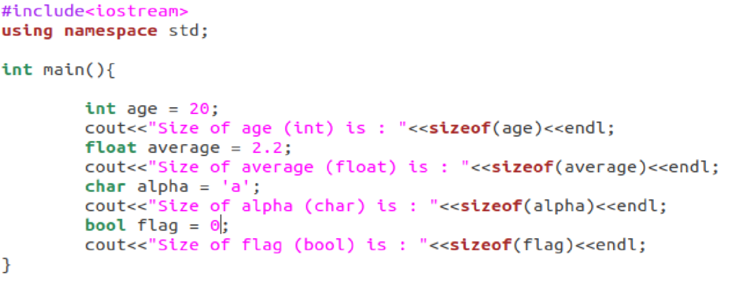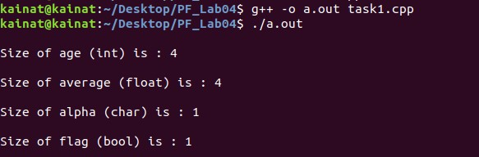

**Example 1.2:**

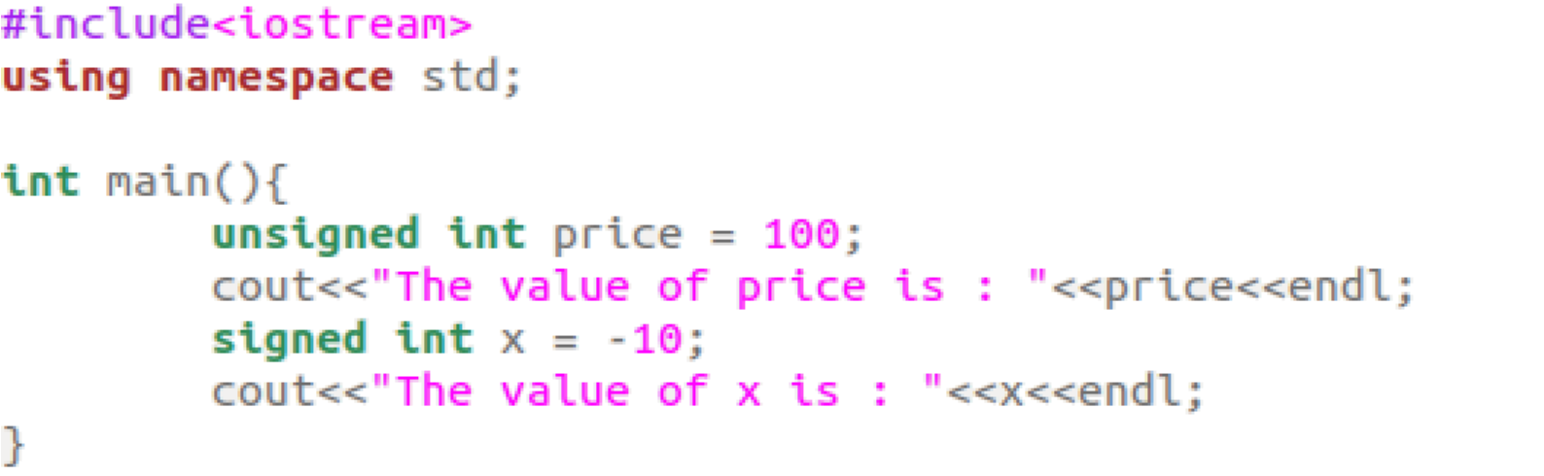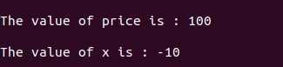

1. **Standard Input (cin):**

**Example 2.1:**

**Example 2.2:**

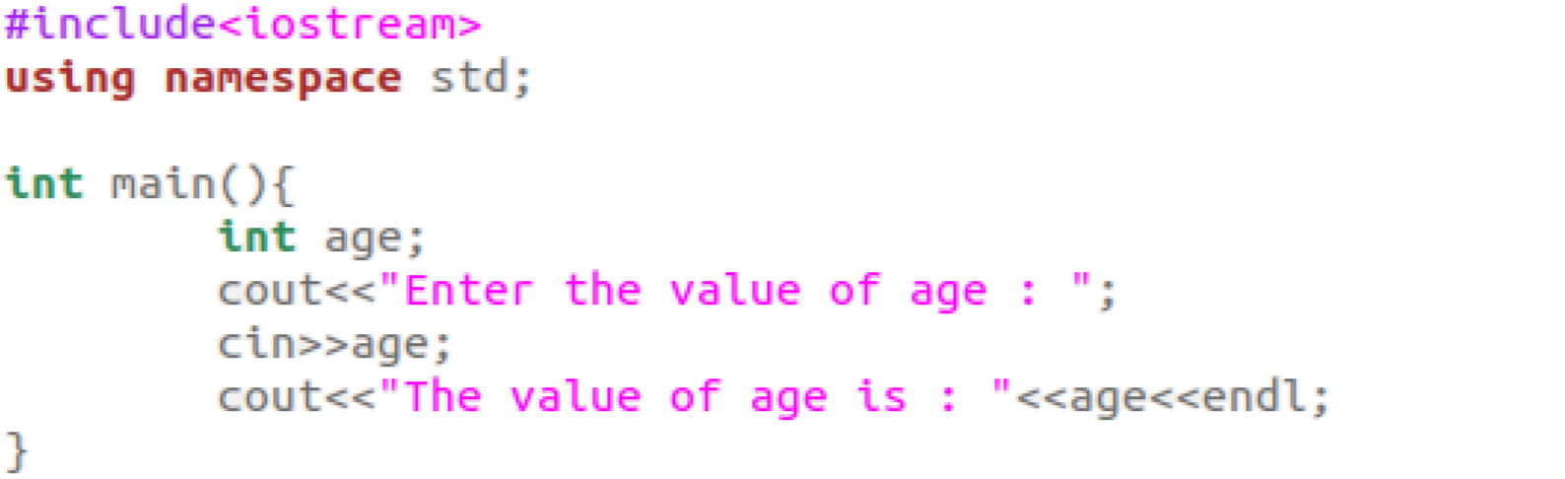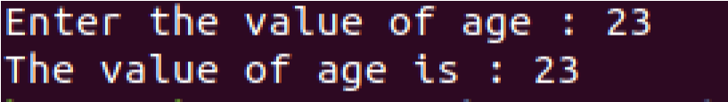

**3)**

**Operators:**

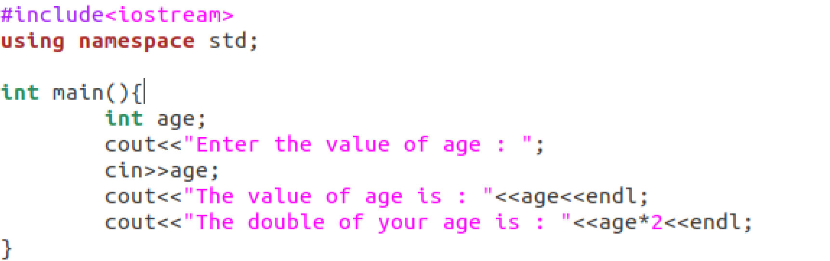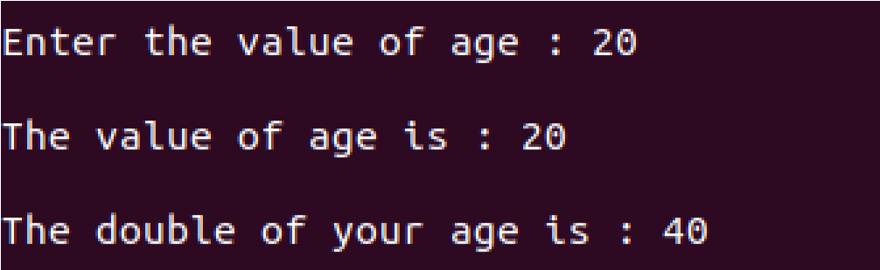

**Arithmetic Operators**

**Example 3.1:**

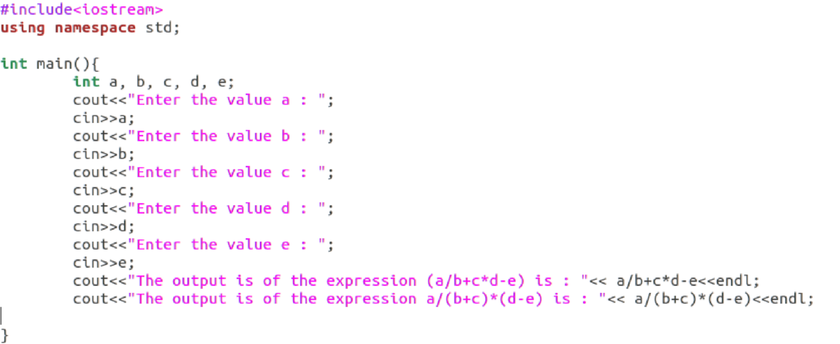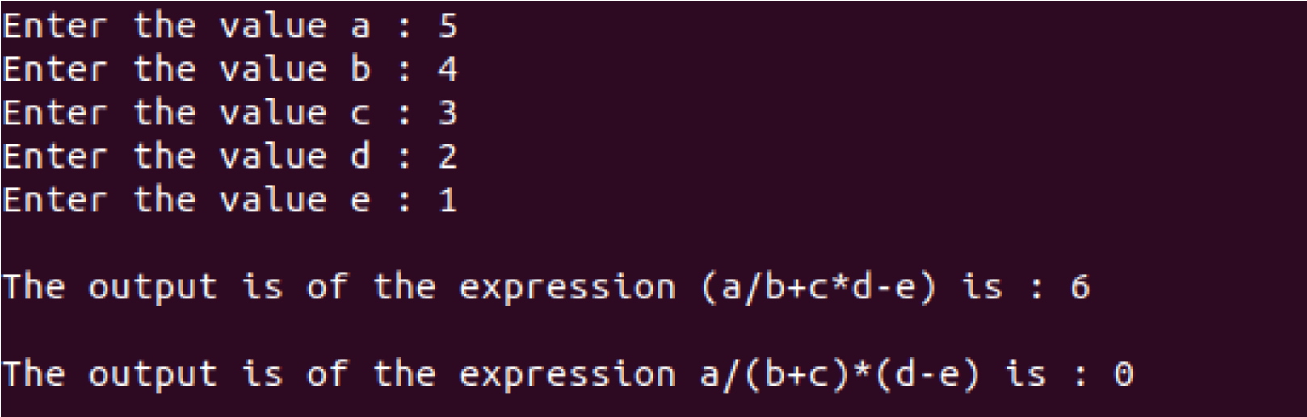

# iomanip

iomanip is a library that is used to manipulate the output of C++ program. Below are some Parametric manipulators

#### setw

It is used to sets the field width to be used on output operations

Example

Now compile your code and see what the output is.

#### setprecision

It is used to sets the decimal precision to be used to format floating-point values on output operations.

Example

Output

**Lab Tasks**

**Problem 01**

Write a program to find circumference of a circle. The program should take radius input from user and display the circumference.

𝑐𝑖𝑟𝑐𝑢𝑚𝑓𝑒𝑟𝑒𝑛𝑐𝑒 = 2𝜋𝑟 (𝑤ℎ𝑒𝑟𝑒 𝑃𝐼 𝑖𝑠 𝑎 𝑐𝑜𝑛𝑠𝑡𝑎𝑛𝑡 𝑣𝑎𝑙𝑢𝑒 𝑜𝑓 3.1415 𝑎𝑛𝑑 𝑟 𝑖𝑠 𝑟𝑎𝑑𝑖𝑢𝑠)

***Note: Declare PI as constant***

**Problem 02**

Write a program for the following mathematical trick:

* Declare an integer variable
* Take input from user and assign the value to the variable
* Double the value of variable and store in the same variable.
* Add 10 to the value of variable and store in the same variable.
* Now half the value of variable and store in the same variable.
* Then subtract the number entered by user from the current value of the variable and store in the same variable.
* Finally display the value of the variable. The answer must always be five.

**Problem 03**

Write a program that asks a shopkeeper to input unit price of chocolate mini bar and stores in a variable. It then asks to input the quantity of chocolates sold in a particular day and store in another variable. Now it calculates and displays the total sales amount of chocolates earned by the shopkeeper. Now calculate 10% tax on total sales amount and store in another variable. Display the total sales amount of chocolates after tax deduction.

**Problem 04**

Write a program to find and display result for whole square of three numbers using following formula in a single expression:

**a2 + b2 + c2 + 2 (ab + bc + ca)**

# Note: Get the values of a, b and c from user. Perform the above task with only one mathematical equation. Keep the concept of operator precedence in mind.

**Problem 05**

### Write a program to print the following using just ONE COUT statement & setw function.

**Problem 06**

Write programs that performs the following operations:

(2*(3-(4*5))) = ?

((2*3)-(4*5)) = ?

1 + 2 * 3 - 4 + 5 + 6 - 7 * 8 - 9 = ?

1 + 2 + 3 + 4 + 5 + 6 + 7 + 8 + 9 = ?

**Problem 07**

Write a program that inputs the time in seconds from the user and display the time in Hours Minutes and Seconds in the following format:

**03 hours : 20 mins : 45 seconds**

Note: 1 hour =60 minutes, 1 min = 60 seconds

|  |
| --- |
| **Submission Instructions:**  1.Save all **.cpp** files with your roll no and task number  **e.g. i22XXXX_Task04.cpp**   1. Now create a new folder/directory with name *ROLLNO_LAB04* **e.g. i22XXXX_LAB04** 2. Move all of your .cpp files to this newly created directory and compress it into **.zip file**. 3. Now you have to submit this zipped file on Google Classroom. |

**THE END**